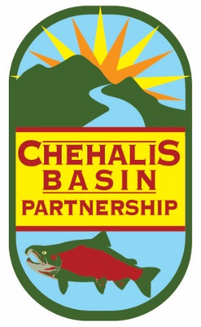
Chehalis Basin Partnership

-- Agenda --

DATE: Friday, October 25, 2019
TIME: 9:30 am to 12:00 pm
LOCATION: ** Fairfield Marriott, 6223 197th Way SW, Rochester, WA 98579 (see directions below)**

WebEx access:
https://meetings.webex.com/collabs/#/meetings/detail?uuid=M0S4PCGVH5PE0ZR59TTDDN611R-G503&rnd=556896.38447

Dial-in access: 1-844-740-1264, Meeting id: 196 402 491

A. Partnership Business | Start Time | Discussion Lead
- Welcome & Introductions | 9:30 am | Terry Harris, Chair
- Approval of September Meeting Summary | 9:35 am | Terry Harris, Chair
B. Presentations & Discussions | Start Time | Discussion Lead
- Permit-Exempt Well 20-Year Projections (Partnership Decision). First reading of proposed permit-exempt well projections were presented and discussed at the Partnership’s September meeting. These include using past building permit trends, OFM projections, and Thurston Regional Planning Council projections (for Thurston County only). Partnership approval of these projections will be sought at this meeting. | 9:40 am | Cynthia Carlstad, NHC
- WebMap Demonstration. NHC/GeoEngineers team have created a WebMap for members’ use. Data layers include land use, water service areas, urban growth areas, subbasins, and projected permit-exempt wells. | 10:15am | Cynthia Carlstad, NHC
Break | 10:30 am
- Consumptive Use Estimates from Projected Permit-Exempt Wells. Consumptive water use must be estimated for projected permit-exempt wells. This consists of indoor and outdoor water use. The Plan Addendum must offset for the consumptive portion of water use. Methods will be presented for information and discussion. | 10:40am | Cynthia Carlstad, NHC, with participation from Demand Forecast Work Group
- Watershed Plan Addendum Progress Reports. Brief progress reports will be provided on the following topics:  - Offset Projects Projects  - Updated Work Plan Overview | 11:30 am | All
C. Other Business and Closing | Start Time | Discussion Lead
- For the Good of the Order / Public Comment. Partner updates, requests, or offers welcome. Partners may also provide written updates to Cynthia by Thursday, October 24 at noon for distribution at the meeting. Public comments are also welcome at this time. | 11:50 am | Terry Harris, Chair
- Adjourn  Next Partnership meeting is December 6. | Noon | Terry Harris, Chair

DIRECTIONS
From I-5 - Take Exit 88. Go West on Route 12 toward Rochester. Turn left at the first stop light on Elderberry St. SW / Old Hwy 99 SW. Just past the ARCO and Jack in the Box, turn right into motel parking lot. Enter the motel lobby to get to the first-floor meeting room.
From the west: Take Route 12 eastbound toward I-5. Just before you reach I-5, turn right at the stop light on Elderberry St. SW / Old Hwy 99 SW. Just past the ARCO and Jack in the Box, turn right into motel parking lot. Enter the motel lobby to get to the first-floor meeting room.
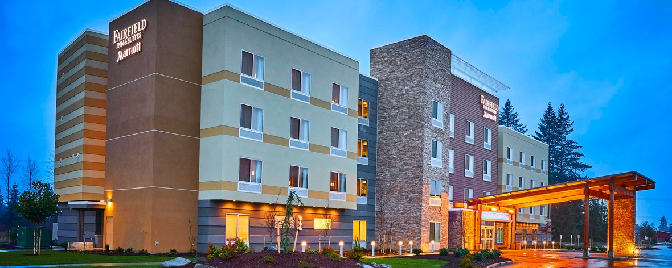

Useful Websites
www.chehalisbasinpartnership.org | Chehalis Basin Partnership
http://chehalisbasinpartnership.org/watershed-management-plan-documents/ | CBP Watershed Management Plan
www.chehalisleadentity.org | Chehalis Basin Lead Entity
www.chehalisbasinstrategy.com | Chehalis Strategy
https://ecology.wa.gov/Water-Shorelines/Water-supply/Streamflow-restoration | Department of Ecology – Streamflow Restoration Site
https://www.coastsalmonpartnership.org/ | Coast Salmon Partnership’s website
http://wa.water.usgs.gov/projects/chehalis/ | Chehalis Basin site sponsored by USGS
https://www.ezview.wa.gov/site/alias__1492/33948/default.aspx | Chehalis River Basin Flood Authority meeting materials

