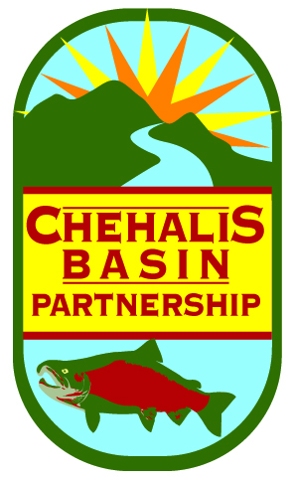
CHEHALIS BASIN PARTNERSHIP
Chehalis Tribe Lucky Eagle Hotel , Sky Room
Rochester, Washington
August 24, 2018
9:30 am – 12:00

Meeting Summary

MEMBERS* and ALTERNATES’ PRESENT
Alissa Shay’, Port of Grays Harbor  Allison Osterberg’, Thurston County  Bobby Jackson*, Lewis County  Cynthia Wilson*, Thurston County  Glen Connelly*, Chehalis Tribe | Jan Robinson*, Chehalis River Basin Land Trust  Fred Evander’, Lewis County  Patrick Wiltzius’, City of Chehalis  Phil Apack*, Port of Grays Harbor  Terry Harris*, City of Chehalis  Wes Cormier*, Grays Harbor County
GUESTS
Devan Rostofer, Ecology, TMDL Lead; Mark Mobbs, Quinault Indian Nation; Caprice Fasano, Quinault Indian Nation; Dave Nazy, EA Engineering; Tye Menser, Thurston County Commissioner Candidate; Andy Gendaszkek; USGS.

STAFF
Kirsten Harma, Watershed Coordinator

FOR MORE INFORMATION
- Meeting summaries are available on the Chehalis Basin Partnership website: www.chehalisbasinpartnership.org
- PowerPoint presentations from this meeting are available on the Chehalis Basin Partnership website: www.chehalisbasinpartnership.org/presentations
MEETING

1. Welcome and Introductions

Chair Terry Harris welcomed everyone to the meeting. Members and guests provided self-introductions.

2. Review of July Meeting Minutes
There were no concerns with the minutes. A quorum was not present.
3. Partner Updates
-Chehalis Tribe is doing invasive species removal. They applied jointly with the Center for Natural Lands Management for a native prairie restoration grant (WCRRI)
-The new Ecology TMDL coordinator did a watershed tour and learned about water quality concerns with Stearns Creek.
-The Chehalis River Basin Land Trust is hosting an art event at the Discovery Trail on Saturday, September 15th (noon-3)
-The Port of Grays Harbor is hosting a salmon run & walk at Friends’ Landing (owned by the Port) Sept 28-29.
-Thurston County is working on a National Estuaries grant to develop a riparian restoration program. Incentives for landowners on private property who have degraded stream areas. It’s a Puget Sound Grant so will likely focus on Puget Sound watersheds, but could be a good modle.
B. Presentations & Discussions

Water Budget of the Upper Chehalis River Basin – USGS – Andy Gendaszek, USGS

USGS conducted groundwater and surfacewater interaction monitoring in 2007. They identified aquifers either gaining or losing water during that study. In 2011, USGS did more work to assess the aquifers’ relations to the river. They also did a well inventory in 2011 to better understand how the ground transmits water. In 2018 they were contracted in part by the City of Centralia to develop a water budget for the upper Chehalis watershed (all tributaries above Grand Mound). Their modeling identified the fate of groundwater recharge: only about 1% is used by wells. Development of a numerical model would allow for building scenarios, for example, to see how change in groundwater pumpage would affect streamflow.

Presentation slides are available on our website: www.chehalisbasinpartnership.org/presentations

Quantifying Consumptive Use of Water from Permit Exempt Wells
-- David Nazy, EA Engineering, Science and Technology Inc.
Mr. Nazy summarized the information needed to address 6091 in the Chehalis Basin. He provided calculations of likely domestic well consumptive use (indoor and outdoor) in gallons/day, and summed up totals over the course of a year. He also provided an estimate of the 20-year projection for exempt well water use. His estimate, based mostly on past growth rates, was the addition of 46 wells a year in the lower basin, and 118 wells per year in the upper basin. He finished his presentation with recommendations for the Chehalis Basin Partnership, which include: coordination among counties; quantifying impacts by sub-basin; screening and prioritizing mitigation actions; and implementing projects.

Presentation slides are available on our website: www.chehalisbasinpartnership.org/presentations

C. Other Business

There was no further business.
ADJOURNMENT

With there being no further business, Chair Terry Harris adjourned the meeting at 11:35.
NEXT MEETING: August 24, 2018

*Next month the meeting will also be held in the Sky Room of the Lucky Eagle Hotel, not in the Casino*

*The September meeting will be an important workshop. Please reserve 4 hours for this meeting. Please plan to attend or send an alternate. Lunch will be provided.

