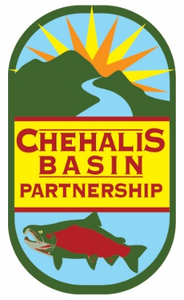

Chehalis Basin Partnership

-- Agenda --

DATE: Friday, October 26, 2018
TIME: 9:30 am to 12:00 pm
LOCATION: **Chehalis Tribe Lucky Eagle Hotel “Sky Room” **Note new location – Hotel, which is across from the Casino. Look for signs to direct you to meeting location.

A. Partnership Business | Start Time | Discussion Lead
1. Welcome & Introductions | 9:30 am | Terry Harris, Chair
2. Approval of September Meeting Notes | 9:35 am | Terry Harris, Chair
3. Partner Updates | 9:40 am | Terry Harris, Chair

B. Presentations & Discussions | Start Time | Discussion Lead
Summary of Net Ecological Benefit workshop (Lacey) & American Water Resources Association (Seattle) | 10:00 am | Mike Noone, Ecology
Follow-Up from September Workshop and Next Steps in Watershed Planning Process  *Summary of CBP’s September Workshop  *Brainstorming for Subcommittees  *Review of draft Timeline  *Outreach to non-active members  *Further discussion on Decision-Making procedures  *Review draft Request for Qualifications for Contractor  *Formation of Selection Committee for Contractor | 10:15 am | Kirsten Harma, Watershed Coordinator
Break | 11:00 am
Presentations: Conceptual Projects Applying for Streamflow Restoration Act funding  *Thurston County Public Works –Mark Maurer  *Grays Harbor County Conservation District –Anthony Waldrop | 11:15 am | Various
C. Other Business
Grays Harbor Stream Team Funding | 11:45 am | Kirsten Harma, Watershed Coordinator
Nominations for Chair and Vice Chair – Due in October  Decide dates for Next Meeting | 11:55 am | Kirsten Harma, Watershed Coordinator

DIRECTIONS

From I-5 - Take Exit 88. Go West on Route 12 toward Rochester. Drive through Rochester and continue 8 miles west until you see the signs for the Chehalis Tribal Center/Lucky Eagle Casino (Anderson Road). Turn left onto Anderson Road and go straight until you reach the stop sign at the intersection of 188th Ave. SW. Turn left on 188th Ave SW to the Chehalis Lucky Eagle Hotel. Park in the Hotel parking lot, on left. To find the meeting room, head in the main entrance and then turn right. Go past the Camas Room and find the elevator. Take the elevator to the fifth floor. The Sky Room door will be open, near the end of the hall on the right.

From Route 8 - Take Route 12 exit. Drive through Oakville and continue east 5 miles until you see the signs for the Chehalis Tribal Center/Lucky Eagle Casino (Anderson Road). Turn right onto Anderson Road and go straight until you reach the stop sign at the intersection of 188th Ave. SW. Turn left on 188th Ave SW to the Chehalis Lucky Eagle Hotel. Park in the Hotel parking lot, on left. To find the meeting room, head in the main entrance and then turn right. Go past the Camas Room and find the elevator. Take the elevator to the fifth floor. The Sky Room door will be open, near the end of the hall on the right.

