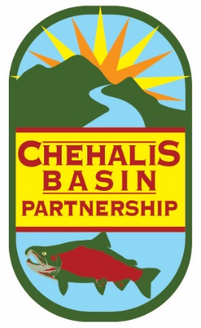

Chehalis Basin Partnership

-- Agenda --

DATE: Friday, January 25, 2019
TIME: 9:30 am to 12:00 pm
LOCATION: **Chehalis Tribe Lucky Eagle Hotel “Sky Room” **

A. Partnership Business | Start Time | Discussion Lead
1. Welcome & Introductions | 9:30 am | Terry Harris, Chair
2. Approval of November Meeting Notes | 9:35 am | Terry Harris, Chair
3. Partner Updates | 9:40 am | Terry Harris, Chair

B. Presentations & Discussions | Start Time | Discussion Lead
Environmental Impact Statement relationship to Chehalis Basin Strategy. Update on the Chehalis Basin Strategy, including the project-level EIS for the Flood Damage Reduction Project and next biennium budget proposal for the whole strategy. | 10:00 am | Andrea McNamara-Doyle, Office of the Chehalis Basin, Ecology
Break | 10:40 am
Hydrogeology 101 – The physical connection between groundwater and surface water will be an important thing to understand as we address how to mitigate for exempt well use. Tom will help us freshen up our hydro-knowledge. | 11:00 am | Tom Culhane, Water Resources Program, Ecology
C. Other Business
Contractor Selection - Recommendation from the CBP Subcommittee tasked with reviewing applications for Streamflow Restoration Act/Watershed Plan update facilitation contractors. Vote. | 11:40 am | CBP Subcommittee
Vote: Chair and Vice Chair | 11:55 am | Kirsten Harma, Watershed Coordinator

DIRECTIONS

From I-5 - Take Exit 88. Go West on Route 12 toward Rochester. Drive through Rochester and continue 8 miles west until you see the signs for the Chehalis Tribal Center/Lucky Eagle Casino (Anderson Road). Turn left onto Anderson Road and go straight until you reach the stop sign at the intersection of 188th Ave. SW. Turn left on 188th Ave SW to the Chehalis Lucky Eagle Hotel. Park in the Hotel parking lot, on left. To find the meeting room, head in the main entrance and then turn right. Go past the Camas Room and find the elevator. Take the elevator to the fifth floor. The Sky Room door will be open, near the end of the hall on the right.

From Route 8 - Take Route 12 exit. Drive through Oakville and continue east 5 miles until you see the signs for the Chehalis Tribal Center/Lucky Eagle Casino (Anderson Road). Turn right onto Anderson Road and go straight until you reach the stop sign at the intersection of 188th Ave. SW. Turn left on 188th Ave SW to the Chehalis Lucky Eagle Hotel. Park in the Hotel parking lot, on left. To find the meeting room, head in the main entrance and then turn right. Go past the Camas Room and find the elevator. Take the elevator to the fifth floor. The Sky Room door will be open, near the end of the hall on the right.

